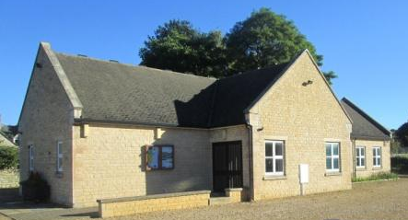 | Tinwell Village Hall (Registered Charity No. 525162)  Manor Lane, Tinwell, Rutland PE9 3FS  Hire Agreement – Weekend Events
This agreement is made on the date (1) and between the Village Hall Committee (2) and the Hirer (3) named below whereby in consideration of the sum(s) mentioned (4) plus refundable deposit:
A: | The Committee agrees to permit the hirer to use the premises (5) for the purpose (6) and for the period(s) all described below (7), viz:
1. | Date
2. | Tinwell Village Hall Management Committee
2b. | Village Hall’s authorised representative: |  | Mrs Bernadette Bulbick
 | Address:
 | Tel no:
 | Email address: |  | tinwellvillagehall@gmail.com
3. | Hirer
 | Organisation (if applicable):
3b. | Name of organisation’s authorised representative:
 | Address:
 | Tel no:
 | Email address:
4. | Hiring Fee:
 | Less Deposit:
 | Balance:
 | Payable on or before the conclusion of the event for which the Hall is hired (the deposit having been paid on the signing hereof).
 | Note: |  | Lighting and space heating is included in the hiring fee.
5. | Premises |  | Whole of Village Hall or Part of Hall only
6. | Purpose of hiring
7. | Period of hiring: Date/s: |  |  |  | Hours:
B: | The hirer agrees with the Committee to be present during the hiring and to perform the provisions and stipulations contained or referred to in the Committee’s Standard Conditions of Hire for the time being in force, as annexed hereto (an understanding of which the hirer acknowledges) together with the special conditions set out in the schedule below (if any).
C: | Special conditions  (if applicable): |  | Please leave the Hall clean and tidy. Place all rubbish in the bins provided outside. Ensure all lights are switched off and all fire doors are closed.
Signed on behalf of Tinwell Village Hall Committee above by the person named (at 2b): |  |  |  |  |  |  | Date:
Signed on behalf of the hiring organisation named above by the person named (at 3b): |  |  |  |  |  |  | Date:

